ELECTRIC WINDSOR SERIES
POWER BATH

Unit weight empty 93kg

Maximum water volume 240ltr

Bath, water and patient maximum weight 375kg

Electrical supply 230V

Maximum fuse rating 5amp

System operating voltage 24V

Contains 2x 12V 1.2Ah batteries (good for approx. four years of service)

Maximum user weight 159Kg (350lbs or 25 Stone)

Suitable for intermittent use only – 2 minutes on – 18 minutes off

STATUS MONITOR

Once connected to a power supply the bath should NOT BE SWITCHED OFF, as the bath will not operate, and the batteries will discharge over a short period of time.

The status monitor GREEN power light should be illuminated on the power status board when power is connected.

When the status monitor shows the AMBER power light it indicates that there is no power to the bath and battery power is in use, whilst running on battery power the seat will only move from inside the bath to the outside lowered position for safety reasons.

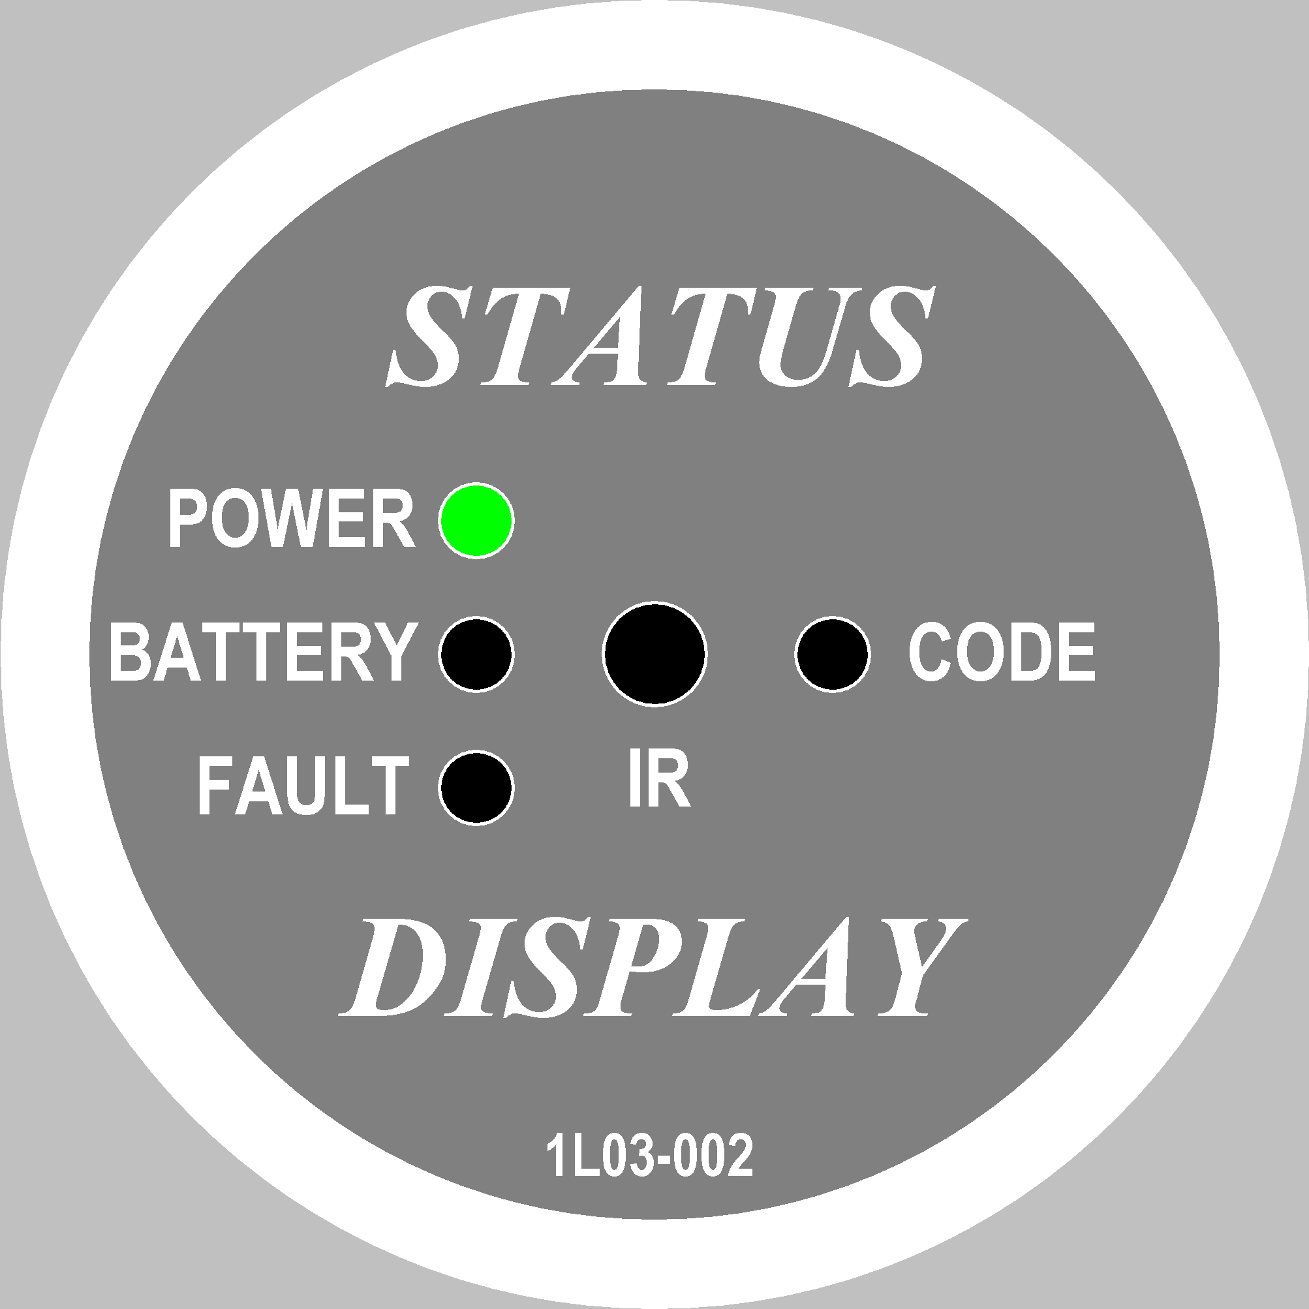
Normal Operation

- Green LED Illuminated.
- Mains power is present and the system is working correctly.

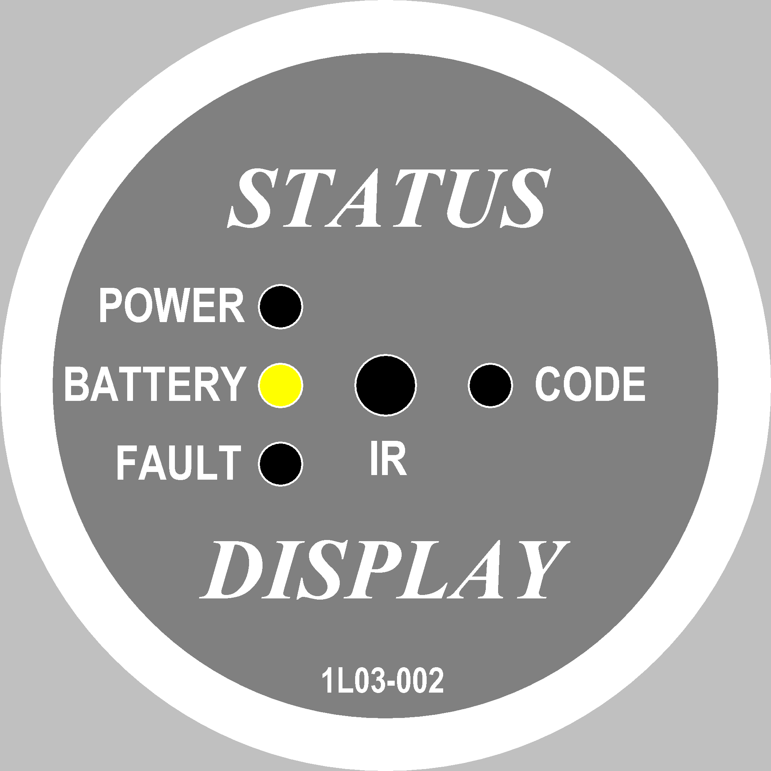
Power Failure

- Yellow LED Illuminated.
- Mains power failure and the system is now working on battery backup.
- Bath will now only operate in the out direction.
- When the bath has reached it’s out position the system will shut down and no LED’s will be illuminated.

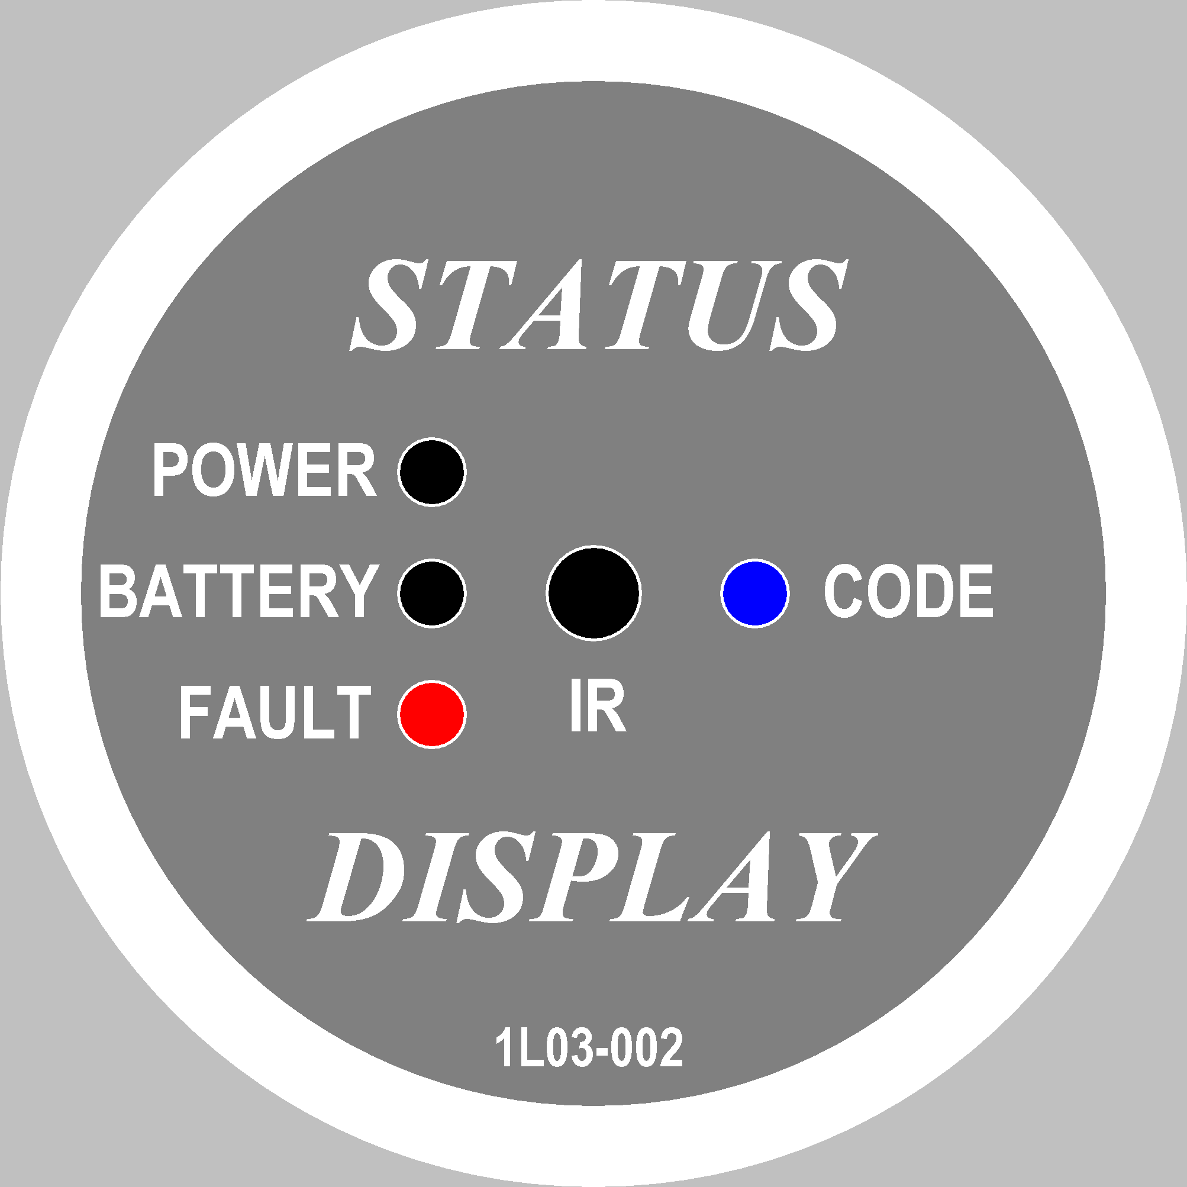
System Failure

- Red LED Illuminated and Blue LED Flashing error code.
- A Fault has occurred with the system and it will no longer continue to operate.
- Switching off the mains power and fixing the fault will only clear the fault.
- A fault code is generated by the flashing Blue LED (see below)

CODE FAULTS

Code 1: Lift actuator: One long flash followed by 1 short flash

---------- ----- ---------- -----

Code 2: swivel actuator: One long flash followed by 2 short flash

---------- ----- ----- ---------- ----- -----

Code 3: Leg lift actuator: One long flash followed by 3 short flash

---------- ----- ----- ----- ---------- ----- ----- -----

FUNCTION TROUBLESHOOTING

Symptom Possible cause Action

No lights showing on the status monitor ● No Electrical supply ● Check Mains power
connection
● Blown fuse in the control box ● Fuse must be changed
● Cable damaged ● Replace cable

Status monitor showing an amber ● Battery power only ● Check Mains power
Light on constantly and seat inside connection
The bath

No lights showing on status monitor, ● See fault code page ● Rectify specified fault
Seat in fully lowered outside of bath
position

Seat will not lift ● Poor cable connection ● Check all connections
● Poor handset air tube connection ● Check all connections
● Crushed or damaged air tube ● Check air tubes are free
from damage/pinching

Seat lifts out of the bath using the ● Air tubes opposed ● Switch air tubes around
In button (bottom button) on control box

Seat will go out of, but not back ● Air tubes disconnected ● Check all connections
Into the bath ● Air switch faulty ● Switch air tube connections
Around to see if other button
returns seat to bath

Seat will not traverse ● Actuator lead unplugged ● Check all connections
● Actuator plugged into wrong port ● Check all connections

CONTROL BOX TROUBLE SHOOTING

Symptom Possible cause Action

No power from PSU/Battery ● Not connected to mains ● Connect to mains
● The fuse has blown ● Replace fuse, or replace
PSU/Battery
● Defective power cable ● Replace PSU/Battery box
● PSU/Battery defective ● Replace PSU/Battery box

Power from PSU/Battery ● Actuator plug not pushed into control ● Push actuator plug into
but actuators do not run. box properly control box properly
● Actuator defective ● Replace actuator and
reprogramme bath
● Control box defective ● Replace control box and
reprogramme bath
● Handset defective ● Send handset for repair

Control box OK apart from one ● Handset defective ● Replace handset
direction or one actuator ● Actuator defective ● recalibrate or replace
actuator and reprogramme
bath

Colour Coding For Cable Identification
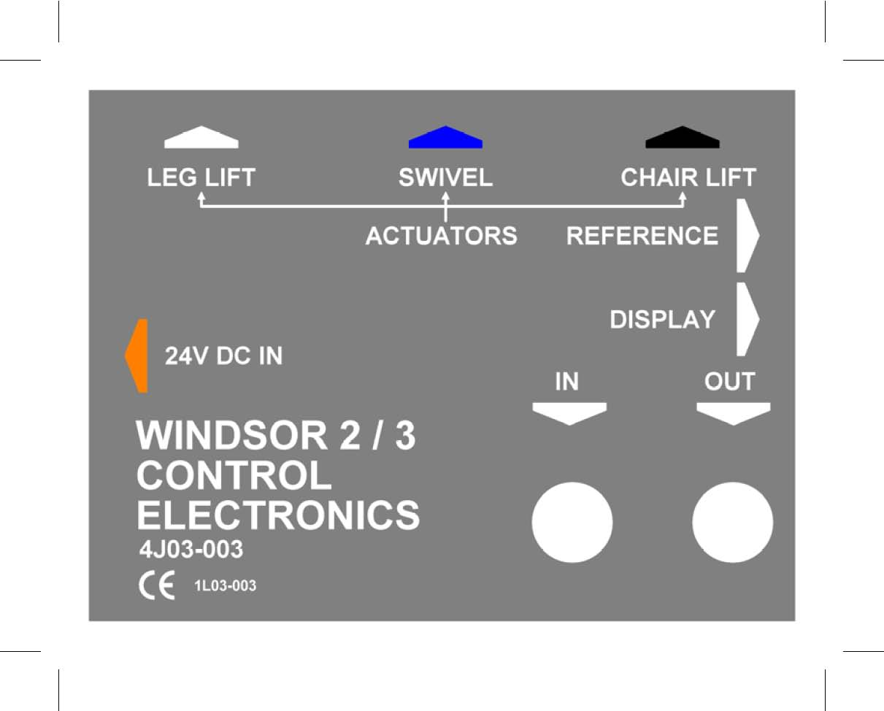

Corresponding colored rings can be found on each actuator lead at the plug end.

